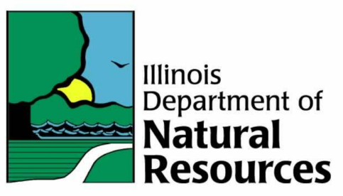
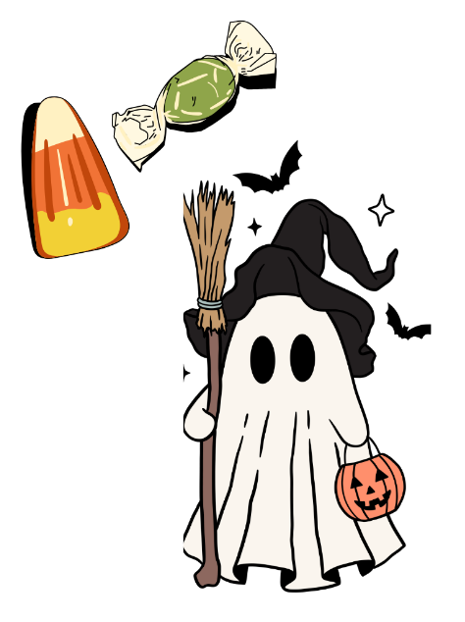
2025 Harvest Festival Participant Registration
Saturday, October 25th | 3 pm – 6 pm
William W. Powers State Recreation Area | 12949 S Avenue O, Chicago IL 60633

Name(s) of Participant(s):
Organization:
Phone (Preferred Contact for Day of Event):
Email(s):

Will you require a table and/or chairs? [ ] YES: Table(s) Chair(s) [ ] NO

Will you require a permit to sell? (I.e., Do you plan on offering items for purchase in addition to free activities/resources) [ ] YES [ ] NO

Please provide a brief description of what you will provide at your table and a brief description of the FREE interactive experience OR giveaways offered:

If you selected yes in needing a permit to sell, please list what materials and estimates of cost you plan to provide:

Are there any dietary restrictions for participating members of your organization that park staff should be aware of? __________________________________________________________________________________________________________________________________________________________________________

Thank you for your interest and participation! We look forward to this festival continuing to create lasting memories for local children and their families alike.

