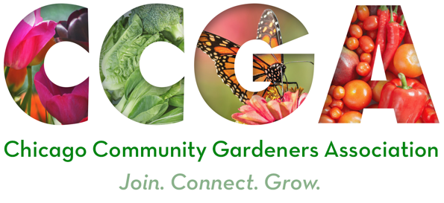
Chicago Community Gardeners Association
9th Annual Spring Conference
March 16, 19, 23, 26 and 30, 2022
Two Virtual Sessions Each Day

Request for Proposals (RFP)
Deadline: February 1, 2022
This Request for Proposals is intended to provide information and guidelines on what we’re seeking in this year’s proposals for the Chicago Community Gardeners Association (CCGA) 9th Annual Spring Conference. Please read this RFP thoroughly to help us create an engaging learning experience for our gardeners through our virtual platform.

Conference Theme
The theme of this year’s conference is Chicago Community Gardens: Our Challenge to Build and Thrive. Over the last two years, community gardens have risen to the challenges faced and have had a profound impact on the health and well-being of their neighborhoods. Gardening has been recognized globally for its benefits to people and the planet. What have we learned and how do we ensure thriving community gardens for Chicago’s future? Bring your challenges; share your visions and solutions!

About CCGA
Our city is home to hundreds of community gardens, and CCGA has created a network of those gardeners that is truly gardener-designed and gardener-led to ensure the sustainability and vibrancy of Chicago gardens for years to come. CCGA is composed of working groups that meet regularly to support community gardens as a vehicle for building sustainable communities and enriching the natural ecosystem in Chicago and beyond. While Chicago's neighborhood gardens are our immediate focus, CCGA has the potential to engage with other areas through our teams of Communication, Education, Resources and Distribution, and Advocacy and Outreach because many issues affect our larger shared environment. To learn more, visit our website.

Presentation Guidelines
CCGA is seeking proposals for web-based presentations for our virtual conference this March. Presentations will be scheduled in two 60-minute time blocks each Wednesday from 5-7 pm and Saturday from 10 am-noon starting March 16 and ending March 30 (see session times below). The virtual format offers wide flexibility and invites presentations that provide engaging and informative content for both seasoned and new gardeners, inspiring and supporting their love of gardening. Beyond this, presentations should challenge gardeners to cultivate sustainable relationships and practices with plants, soil and people that will contribute to the well-being of their gardens, communities and the environment.
- Proposals will state the goal of the presentation and clearly describe how the presentation will benefit community gardeners in terms of how they may apply what they learn.
- A "how to or hands on" presentation must be rooted in “best practices” with approaches for community gardens. Technical workshops must have a scientific basis.
- A presentation must be free of cultural appropriation and gender or racial bias.
- Spanish language presentations are highly sought by our attendees.

- Categories for proposals may also include leadership, neighborhood advocacy, community organizing strategies, social and environmental stewardship, volunteer recruitment and retention, and gardening with youth.

Conference Format and Technical Requirements
This year’s conference will be a series of live Zoom presentations which will be available for viewing by attendees after the conference. All presentations should be moderated. Moderator tasks include: welcome attendees, manage the chat, and act as timekeeper, etc. If you have a reliable moderator/facilitator to accompany your presentation please inform us so we can add them to our moderating team.
With any virtual platform, there are some technical requirements to ensure a successful presentation. The CCGA communications team will work to support all presenters and conduct practice sessions on Zoom prior to the conference. The requirements are:
- Internet connectivity with adequate bandwidth
- Laptop/desktop computer with good quality microphone and video camera
- Prepared digital presentations and ability to screen share, if needed

Presentation Format & Schedule
Please select your presentation format:
__ Workshop __ Lecture __ Demonstration __ Panel __ Other (describe in proposal)

Please select your session time. If you can be flexible, please indicate this in your proposal:
Wednesday, March 16 __ 5-6 pm __ 6-7 pm
Saturday, March 19 __ 10-11 am __ 11 am-12 pm
Wednesday, March 23 __ 5-6 pm __ 6-7 pm
Saturday, March 26 __ 10-11 am __ 11am-12 pm
Wednesday March 30 __ 5-6 pm __ 6-7 pm

We would like to honor your request for a specific session time, so please return this form ASAP to ensure your selection is available.

Questions, Submission & Notification of Acceptance
Please send your proposal to Lorraine Kells at lxkells@gmail.com by 5pm on February 1, 2022.

If you have any questions prior to your submission, please contact Lorraine Kells at lxkells@gmail.com. Additionally, the Communications Team will be available to answer any questions you have about the technical aspects of your proposal.

You may be contacted by phone or email if there are questions or clarifications needed for your proposal. A notification of acceptance will be sent by February 5. Each presenter will be asked to provide a brief biography, current contact information including phone and email, and a recent photo upon notification of selection to be used for conference promotional materials. Substitutions must be given in a timely manner and be approved prior to the conference date.

The CCGA Education Team extends its thanks to you!

