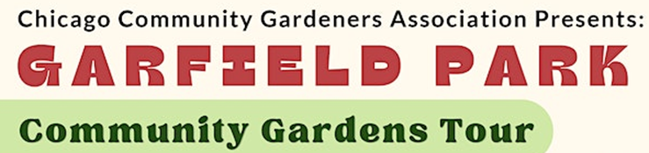

Did you know that Garfield Park has been growing fresh local food in community gardens and marketing it since 2007. YES NO
On a scale of 5 (excellent) and 1 (unsatisfactory), how would you rate your experience today? ____
Were the gardens selected for the tour of interest to you? YES NO
Which of these locations did you visit for the first time today?

Madison Street Vegetable Garden
Limes Smiles for Miles
Kuumba Tre-Ahm
Fulton Community Garden
Garfield Park Neighborhood Market
The Hatchery

Would you like CCGA to host more community garden tours in the future? YES NO

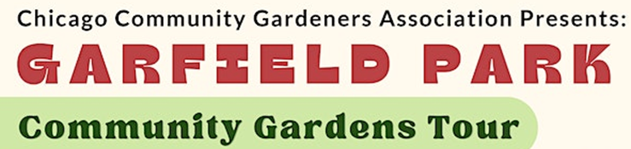

Did you know that Garfield Park has been growing fresh local food in community gardens and marketing it since 2007. YES NO
On a scale of 5 (excellent) and 1 (unsatisfactory), how would you rate your experience today? ____
Were the gardens selected for the tour of interest to you? YES NO
Which of these locations did you visit for the first time today?

Madison Street Vegetable Garden
Limes Smiles for Miles
Kuumba Tre-Ahm
Fulton Community Garden
Garfield Park Neighborhood Market
The Hatchery

Would you like CCGA to host more community garden tours in the future? YES NO

