For Sale
Kinnikinnick Farm’s
FarmStay Tents
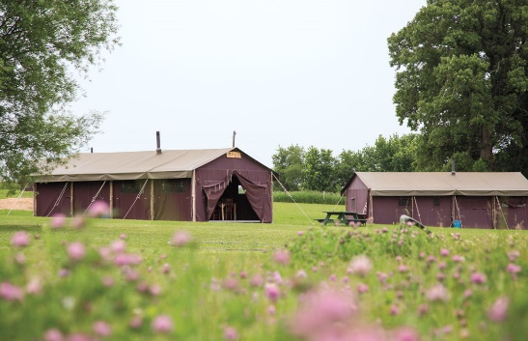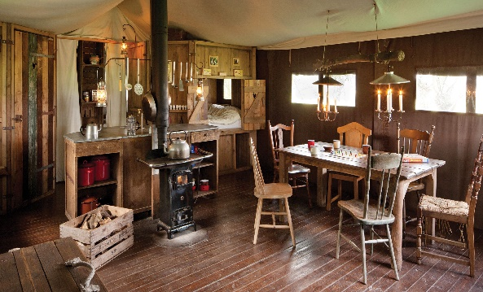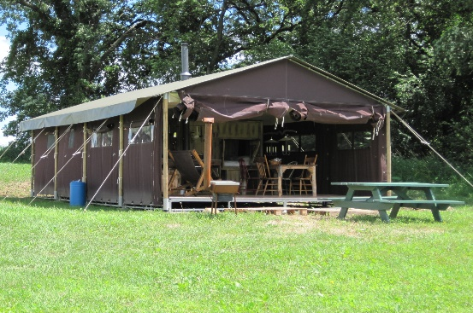

These are the original FeatherDown (Borenbed) tents used on Farms throughout Europe and the UK. They have been the backbone of our Family FarmStay hospitality business at Kinnikinnick Farm since 2011. It has been a good business for us.

We have 5 tents and run 2 stays a week per tent (Tues-Thurs; Fri-Sun). Each tent grosses about $2,000 a week. We book out our entire 22 week summer season in February. We are in our 80’s and retiring from the on-farm hospitality business.

The tents are designed for a family of 5 or 6 people. Each tent has a simple kitchen area, cookware, woodstove/cookstove, master bedroom, bunkbed room, cozy full size cupboard bed tucked into the wall, utility closet, storage chest, a dining area with table, six chairs and tableware for 6. These are not knockdown safari tents designed to be moved. They are a heavy-duty construction designed to stay in place. They are not, however, attached to the ground, so they do not become part of a real estate tax base. In Europe they are called “Canvas Lodges.”

3 tents are for sale. We are keeping 2.
Price:
$13,500 per tent, if purchased individually.
$ 9,500 per tent for 3 tents ($28,000 total).
We will help dismantle and reassemble tents. Buyer pays moving costs.

New, the tents cost $22,000 FOB Amsterdam. Add transatlantic shipping, delivery, construction and the total cost will be north of $30,000 each. FeatherDown valued our tents at $27,000 apiece in 2011.

The 3-tent package includes access to us for a year, our customer lists, our management systems, our list of suppliers, etc. Our intention is to: (1) remove the tents from our farm so we won’t be tempted to do another season; (2) price them low enough to enable another small-farm family or couple to add a profitable FarmStay to their farming enterprise.

Run the numbers. If you think a FarmStay might work for you and would like to discuss this further and/or see the tents, give me a call (or email). The tents will be in full use and available for viewing weekdays until Friday noon until the end of our season, October 4.

David Cleverdon
815-509-7278 (mobile)
kinnikinnickfarm@gmail.com

