Let’s Get Growing Outline
Saturday, March 15 from 1-2:30 pm
Garfield Park Conservatory Community Room

Basic Class Outline
Shemuel’s Presentation Notes

Producing Sweet Potato Slips – 10 minutes

The sweet potato is a warm-season, spreading vegetable of tropical origin. Sweet potatoes are grown from slips, which are sprouts that are grown from stored sweet potatoes. You can buy slips from garden centers, nurseries, or local farmers.
It is a good choice for a garden because it is easy to grow. It is drought and heat tolerant, and has few pests or diseases. The sweet potato is also very nutritious and low in calories.

Remember: Sweet potatoes are heat loving plants.

What are slips?

A slip is a single plant (with small roots) that is sprouted on the sweet potato root plant and then slipped off so that you may plant it in the garden to grow sweet potato roots.

How to grow your own slips

Select a healthy (no blemishes or splits) medium sized sweet potatoes from last year’s crop or purchase organic potatoes from a local farmer or farmer’s market in October or November. These sweet potatoes have not been treated with growth retardants and should germinate well. Store them until about 90 days from the last spring frost date. I have two varieties from last year’s crop:

- Memphis Pride: (Heirloom Variety) Mid-season. Vining, cut leaf, pinkish skin, light orange flesh, above average yields.

- Red Wine Velvet: (Heirloom Variety) Mid-season. Vining, normal leaf, deep red skin, orange flesh, average yield.

Ways to start slips:

- Place the sweet potato (pointed end down) in a wide mouthed mason or similar type jar. Use three toothpicks so that the potato will rest on the jar.
- Plant the sweet potato in a 2/3 soil and 1/3 sand mixture. If you are only planting a few slips in your garden, you can plant up to two sweet potatoes in a 1 and ½ gallon pot. I plant four to six sweet potatoes in an 11 by 22 tray.
- The water should be room temperature or warmed to about 80 degrees. Temperatures above 80 degrees promote the germination of the sprouts.
- Root growth is enhanced when you use purified and mineralized water.
- Temperatures above 75 degrees promote the elongation of slips

Each medium sweet potato root will produce a minimum of 12 slips which will produce about 60 to 72 sweet potatoes.

Removing the slips from the potato:

- When your slips grow about three to four inches, it is time to either cut them close to the node or break them off at the node.
- If you have limited space for planting sweet potatoes, you can let your slips grow six to twelve inches tall and then break them off at the node.
- In our garden, we plant three to five 28 feet by 4 feet wide raised beds. We need approximately 150 slips for ourselves and each year we have given an equal amount to other gardeners. Therefore, we cut them off close to the node. This allows faster re-growth and we can produce more slips.

Rooting the slips:
- You can root these slips in water or in soil. I root my slips in water first. Then I plant them in 2.5 inch black form pots.
- Again, I use mineralized filtered water that is energized with a 1200 gauss magnet.
- Last year I had the opportunity to use rain water for the sweet potato slips that we grew in the greenhouse. The slips that I grew in my kitchen still outgrew the slips I grew in the greenhouse.

Tips for planting:
- Once your slips establish its roots in the soil and the ground has warmed to about 70 degrees, it is time to plant them. Sweet potatoes grow well in many types of soil. We prefer a fertile loamy soil; it is easily growing medium for sweet potatoes and it makes harvesting easy. We have used well aged composted horse manure for the past eight years.
- Do not set the plants out when it is very cool.
- You do not need lots of roots on the slips for success. In fact, if you’re just cutting your slips soon after the date of the last frost (May 15), you can root them and plant them directly in the soil. Water the transplant hole and check on them frequently during that first week. You have until the last week in June to plant your sweet potatoes.
- It is not the number of days nor is it the planting zone we’re in that determines success for sweet potatoes. Success is determined by heat units.
- It takes about 1200 heat units during the growth season to produce a decent crop of medium to large sweet potatoes.
- Daily heat units may be calculated: high temperature + low temperature divided by two. Then subtract 55 for the number of heat units for that day.

Example: Daytime high is 80 degrees and the nighttime low is 70 degrees.
80 + 70/2 = 75 -55 = 20 heat units.

Harvest and Storage

You can start digging up your potatoes in late September or early October. This often represents 90 to 110 days. Cut off the vines at the point where you planted the slip. My favorite method of harvesting is to treat it as an archeological dig. The skin of the potato is extremely delicate and easily bruised. Since the roots spread 4 to 6 inches deep in the soil, a trowel is useful when digging up the potatoes.

Shake off any excess soil but do not wash the potato.

To cure the sweet potatoes, they need a warm (80 degrees) humid place for about two weeks. If the weather is still nice, you can lay them on a tarp and cover them with a cover cloth. Another way of curing them is to place them on a closet shelf and leave the light on. Hang some damp towels in the closet.

To store your potatoes for six months to a year, line a produce box with newspaper, place a layer of potatoes in the box, and cover them with another layer of newspaper. Then store them in a place where the temperature is at least 55 degrees but no more than 60 degrees.
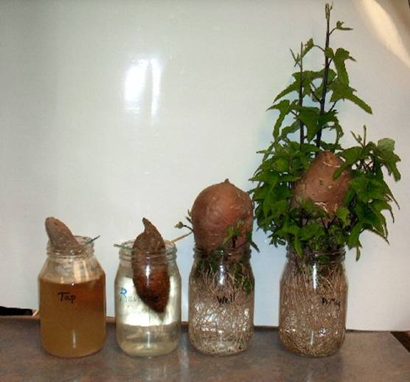
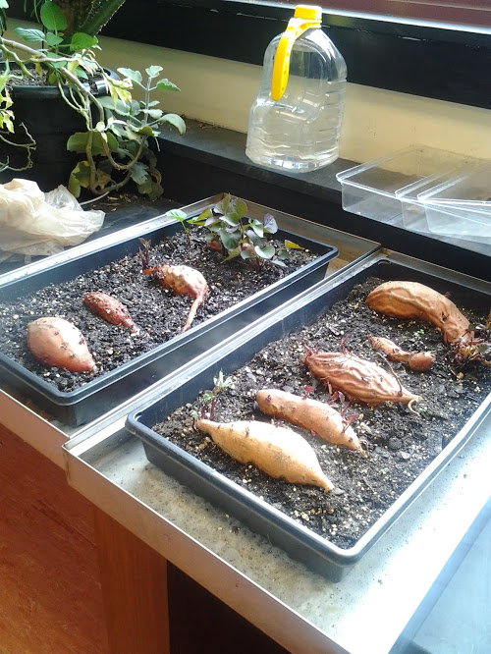
Rooted slips ready to plant in soil
Rooting slips in a jar
Sweet Potatoes: Plant in jar method
Sweet Potatoes: Plant in soil method
Producing Your Own Sweet Potato Slips

