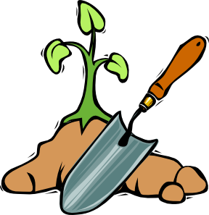

Do you love gardening? Do you love stories? Then we have an evening of fun just for you!

Join us on for a special workshop celebrating your stories about the power of gardening.

No experience necessary, light snacks will be provided!

- Monday, June 23 at Fulton Garden (4427 W Fulton)
- Thursday, June 26 at Ruby Gardens (1557 W Schreiber)

All events will be from 6:00 to 8:30pm.

Led by 2nd Story (www.2ndStory.com) and members of the local gardening community, this workshop is the beginning of a process to generate a storytelling performance for the American Community Gardening Association’s 35th Annual Conference, being held in Chicago August 7-10, 2014.
More information will be provided at the workshop, but individuals who might like to develop work for the performance will also be required to be available on Saturdays July 12th, 19th, and 26th from 10am-12:30pm, for rehearsals between 7/26 and 8/10, as well as for the performance on August 10th.
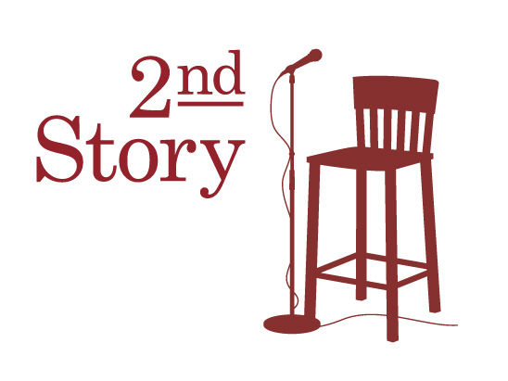
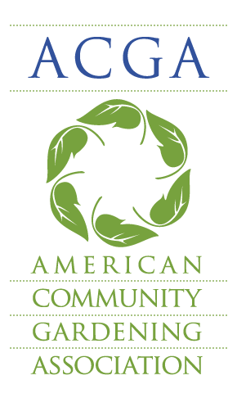
Participation in the performance is NOT REQUIRED to attend this kickoff workshop, so please join us even if you’re not able (or not interested in) participating in the larger scope of the project!
We can’t wait to hear your stories!

